KAMPALA JUNIOR ACADEMY
HOLIDAY WORK SET THREE TERM I 2020
PRIMARY TWO
NUMBERS

My name is ______________________________________________
School ___________________________________________________

1 (a) Draw a set of seven trees.

(b) Name this set.

___________________

2. Add:

(a) 6 cups + 4 cups = ___________

(b) T O
4 3
+ 5
_________

3. Write in words
(a) 25 ____________________________
(b) 2nd ____________________________
(c) 1 _____________________________
4
4. Find the missing numbers in the sequences.
(a) 2, 4, 6, ___, ___, 12

(b) 10, 20, ___, 40, 50, ____

5. Subtract
(a) 3 3kg (b) sh. 8 0 0
- 1 0kg - sh. 3 0 0
_________ _________

6. (a) Name the shapes.

__________________

(b)
__________________

7. Complete correctly.

(a) 3 tens 0 ones = ______________

(b) 3 2 1 = ____ hundreds _____ tens _____ ones

8. Multiply:
(a) 6 x 2 = ________

- 2 3
x 2
_____

9. (a) Name the shaded fraction.

_____________

(b) Name the unshaded fraction.

10 Fill in the missing numbers.
(a) - 5 = 7

(b) 8 + = 12

11. (a) Expand this number.
94 = ____ + ____

(b) What number has been expanded?
100 + 20 + 3 = __________

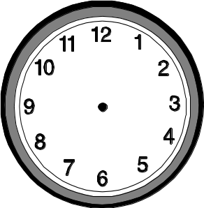
12. (a) Tell the time.

____________________________

(b) Show the time.

It is 4 O’clock.

13. Write in figures.
(a) Seventeen _____________

(b) Thirty six ___________

(c) Third ____________

14. Work out using a number line.
(a) 5 + 4 = ______

0 1 2 3 4 5 6 7 8 9 10

- 7 - 3 = _______

0 1 2 3 4 5 6 7 8 9 10

15. Divide:
(a) 2 10 (b) 15 ÷ 3 =

16. (a) What number is shown on the abacus?
H T O

=
_____________

(b) Show the number on the abacus.
H T O
426

____________
17. Compare their weight.
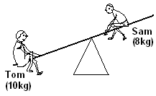
(a) Who is lighter?
______ ____________________________
Babra 13kg

(b) Who is heavier?
Max 22kg
___________________________

(c) What is their total weight?

18. Study the price list and answer the questions below.
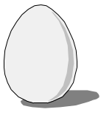

Pawpaw An egg An apple

Sh. 600 sh. 300 sh. 500
(a) How much will you pay for an apple?

(b) Find the total cost of a pawpaw and an egg.

(c) What is the cheapest item?

19. A boy has 12 hens. A girl has 7 ducks. How many birds do they have altogether?

20. There were 23 eggs in the basket. 11 eggs got broken. How many eggs remained in the basket?

21. Share twelve cakes equally among three girls. How many cakes will each girl get?

22. A bird has 2 legs. How many legs do 6 birds have?

23. Write down the place value of the circled digit.
(a) 5 8

(b) 7 5 2

24. How many months make a year?
____________________________________________________

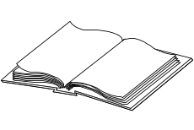
25. The graph below shows books given to four boys by the headmaster.
Okello
Wasswa
Musa
Adam

(a) How many books did Wasswa get?

(b) Who got more books, Musa or Adam?

(c) Find the total number of books given to the four boys.

Good luck

